**Mobile Software Design Document**

**Jianyu He**

**D17124591**

Use Case Design

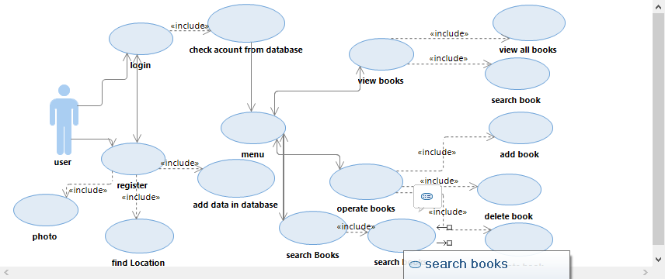

1. user can login in login screen and register in register screen.
2. If user don’t have a account can go to register screen from login screen, if user register already can go to login screen from register screen.
3. When user register a account, the data always goint to database.
4. When user register a account allow to use android features camera to make head portrait for register.
5. When user register a account allow to user android features location tracker to find address.
6. When user login a account, always check user name and password from database.
7. When user name and password is true, then go to menu screen.
8. Menu screen include view book, operate book and search book button, those button can go to different screen.
9. View books screen include operation “view all books” and allow back to menu screen.
10. Operate books screen include operations “add book”, “delete book” and “update book” and allow back to menu screen.
11. Search books screen include operation “search books” and allow back to menu screen.

Class Diagram Design

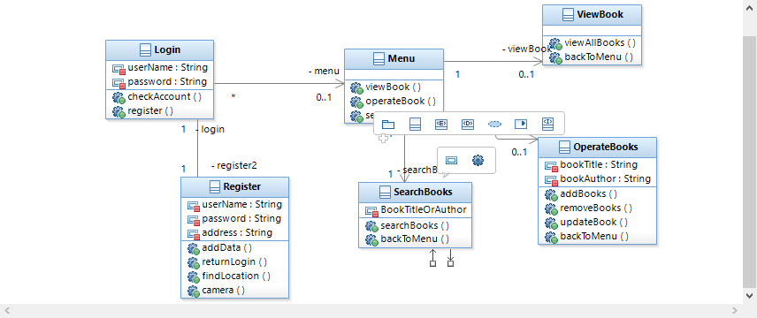

There is 5 class for class diagram, and relationship between each class. Each class contains attributes and operations.

Database Design

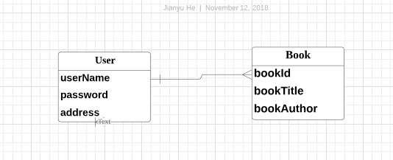

There is my database design, there have 2 tables user table and book table, user table have 3 columns address, username and password, book table have 3 columns bookid, booktitle and bookAuthor. User and book is one to many relationship.

Screen Flow

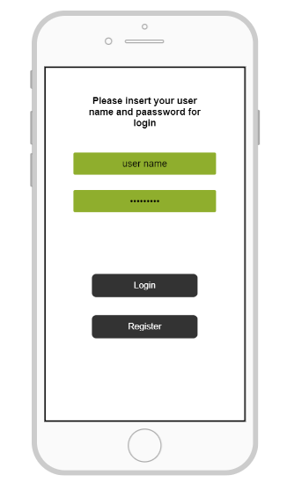

This is login screen, this screen have 2 text field, first is for enter user name, second is for enter password. There are 2 button, click login button to login, click register button return to register screen.

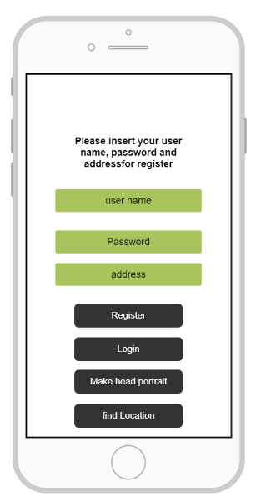

This is register screen, this screen have 3 text field, first is for enter user name, second is for enter password and third is for enter address. There are 4 button, click login button return to login screen, click register button to register, click make head portrait to open android feature camera to make head portrait and click find location to allow use android feature location tracker to find your location for enter address.

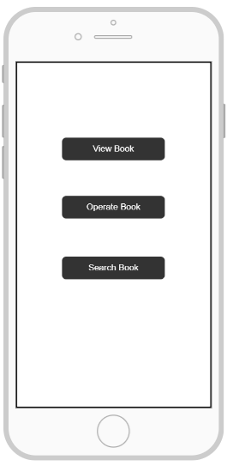

This is menu screen, this screen have 3 button. Click view book go to view books screen, click operate book button go to operation book screen, click search book go to search book screen.

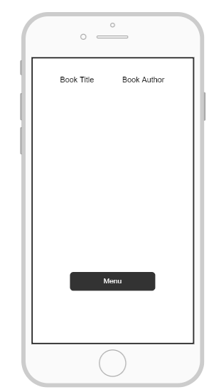

This is view book screen, this screen use for view all books from database, is will list book title and book author. When you click menu button will return menu screen.

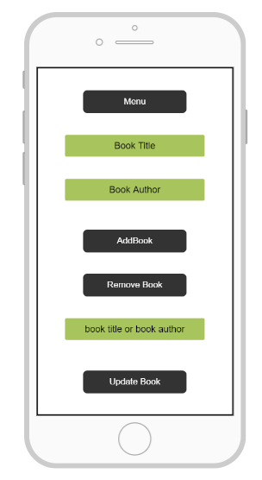

This is operate book screen, you can insert book title and book author to add book and remove book, if you want update book you have to insert third text field, first text field and second text field to update. Third text field is which book you want update, first and second text field is what you want update to.

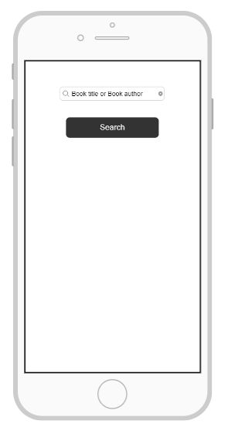

This is search screen, insert book title or book author and click search button to search book.